**Table name: Directors**

**Description: Used to store Directors Information**

|  |  |  |
| --- | --- | --- |
| **Attribute** | **Data Type** | **Constraints** |
| Id | Int(5) | Primary Key/ Not Null |
| Name | Varchar2(40) | Not Null |

* create table Directors(Id int primary key,Name varchar2(40) not null);

**Table name: Stars**

**Description: Used to store Stars Information**

|  |  |  |
| --- | --- | --- |
| **Attribute** | **Data Type** | **Constraints** |
| Id | Int(5) | Primary Key/ Not Null |
| Name | Varchar2(40) | Unique |
| About | Varchar2(100) |  |

* create table Stars(Id int primary key, Name varchar2(40) unique,About Varchar2(100));

**Table name: Movies**

**Description: Used to store Movies Information**

|  |  |  |
| --- | --- | --- |
| **Attribute** | **Data Type** | **Constraints** |
| Id | Int(5) | Primary Key/ Not Null |
| Title | Varchar2(40) |  |
| Year | Int(4) |  |
| Image_url | Varchar2(100) |  |
| Certificate | Varchar2(40) |  |
| Runtime | Int(5) |  |
| ImdbRating | Float(3,1) | By default 0 |
| Description | Text(100) |  |
| Metascore | Float(3,1) | By default 0 |
| Votes | Int(10) | By default 0 |
| Gross | Number(10,2) |  |

* create table Movies(Id int primary key,Title Varchar2(40) not null,R_date Date,Image_url varchar2(100),Certificate Varchar2(20),Runtime Number(3,2),ImbdRating Number(3,1) default 0,Description Varchar2(100) default null,Metascore Number(3,1) default 0,Votes Int default 0,Gross Number(10,2),check (Gross>10000));

**Table name: MoviesDirectors**

**Description: Used to store Movie Directors Information**

|  |  |  |  |
| --- | --- | --- | --- |
| **Attribute** | **Data Type** | **Constraints** |  |
| MoviesId | Int(5) | Foreign Key references  Id of **Movies** table | Primary Key |
| DirectorsId | Int(5) | Foreign Key references  Id of **Directors** table |

* CREATE TABLE MoviesDirectors (MoviesId INT,DirectorsId INT,FOREIGN KEY (MoviesId) REFERENCES Movies(Id),FOREIGN KEY (DirectorsId) REFERENCES Directors(Id));

**Table name: MoviesStars**

**Description: Used to store Movie Stars Information**

|  |  |  |  |
| --- | --- | --- | --- |
| **Attribute** | **Data Type** | **Constraints** |  |
| MoviesId | Int(5) | Foreign Key references  Id of **Movies** table | Primary Key |
| StarsId | Int(5) | Foreign Key references  Id of **Stars** table |

* CREATE TABLE MoviesStars (MoviesId INT, StarsId INT,FOREIGN KEY (MoviesId) REFERENCES Movies(Id),FOREIGN KEY (StarsId) REFERENCES Stars(Id));

ALTER TABLE Stars ADD DOB DATE;

* Drop the column ‘Gross’ in **Movies** table.

ALTER TABLE Movies DROP COLUMN GROSS;

DESC MOVIES;

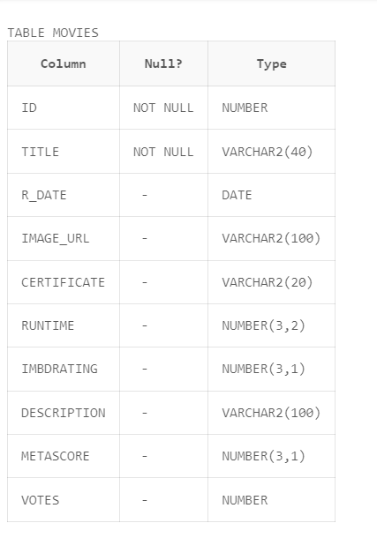

* Add column ‘Language’ in **Movies** table.

ALTER TABLE Movies ADD Language VARCHAR(40);

TABLE MOVIES

|  |  |  |
| --- | --- | --- |
| **Column** | **Null?** | **Type** |
| ID | NOT NULL | NUMBER |
| TITLE | NOT NULL | VARCHAR2(40) |
| R_DATE | - | DATE |
| IMAGE_URL | - | VARCHAR2(100) |
| CERTIFICATE | - | VARCHAR2(20) |
| RUNTIME | - | NUMBER(3,2) |
| IMBDRATING | - | NUMBER(3,1) |
| DESCRIPTION | - | VARCHAR2(100) |
| METASCORE | - | NUMBER(3,1) |
| VOTES | - | NUMBER |
| LANGUAGE | - | VARCHAR2(40) |
| Change the name of the column ‘’ in **Movies table** to ReleaseYear. |  |  |

TABLE MOVIES

|  |  |  |
| --- | --- | --- |
| **Column** | **Null?** | **Type** |
| ID | NOT NULL | NUMBER |
| TITLE | NOT NULL | VARCHAR2(40) |
| RELEASEDATE | - | DATE |
| IMAGE_URL | - | VARCHAR2(100) |
| CERTIFICATE | - | VARCHAR2(20) |
| RUNTIME | - | NUMBER(3,2) |
| IMBDRATING | - | NUMBER(3,1) |
| DESCRIPTION | - | VARCHAR2(100) |
| METASCORE | - | NUMBER(3,1) |
| VOTES | - | NUMBER |
| LANGUAGE | - | VARCHAR2(40) |